ACUME Sdn. Bhd
e-Learning



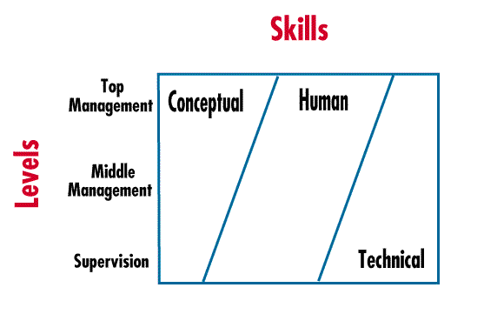
- Leadership is the ability influencing team members to work as a cohesive team in achieving mutually beneficial personal and organization goals and vision
- Power of Observation
Watch your thoughts, they become words
Watch your words, they become actions
Watch your actions, they become habits
Watch your habits, they become character
Watch your character, it becomes destiny

Lead from Within
- To know how other behave takes intelligence; to know myself takes wisdom.” - Lao Tzu
- Nothing so conclusively proves a man’s ability to lead others as what he does day to day to lead himself.
- Intellectual and Emotional Maturity
React
External Events
Behave Negatively

Response
External Events
Behave Positively

Responsibility = Response + Ability

Work Attitude
- What is work? Whenever I put my resources, especially personal resources, into getting what I want for my life.
My Work Attitude
Work is human beings greatest function
I am nothing, I can achieve nothing, fulfil nothing without working
When I am poor – work,
When I am rich – work,
When I am burdened with unfair responsibility - work
When I am happy - work, when disappointments come – work,
When health is threatened- work
When faith falters – work
When dreams are shattered- work
No matter what else I do – work
Work faithfully, work conscientiously,
Work is the greatest remedy available for both mental and physical problems
Therefore, I work, work and work
ACUME Sdn. Bhd
e-Learning

5 Deepest Human Psychological Wants
- Want to be happy
- Want to live and live long
- Want to feel important
- Want a little variety
- Want to be loved

6 Deepest Human Psychological Needs
- To be acknowledged
- To be trusted
- To be respected
- To be loved
- To be understood
- To be heard

Leading and Motivating
  - None of us is as smart as all of us
  - Every business is basically a people business
  - Business problems are basically people problems
  - People don’t get along because they fear each other. People fear each other because they don’t know each other. They don’t know each other because they have not properly communicated with each other. - Martin Luther King, Jr

  - Real communication happens when people feel safe
  - Trust and congruency
  - Earn people’s respect
  - People with humility don’t think less of themselves, they just think of themselves less
  - Leaders are Readers
  - Perpetual prosperity comes to those who help others
  - Help Team Members To Think Better of Themselves
  - The key to developing people is to catch them doing something right
  - You get from people what you expect
  - Help Create A Conducive Environment
  - If you want your people to be responsible, be responsive.
  - Without a chance in behavior, just I’m sorry is not enough
  - Think big, act big and be big
  - Leadership is not something you do to people, it is something you do with people
  - Leadership success depends on the ability to communicate with people, listen to people, attract people, influence people, inspire people, enrich people, help people, profit people and love people

  - Different strokes for different folks. Only people can give other people the ‘tions’ that people need
  - People need positive values to sustain team relationship

12, SS2/75, P.J., Selangor 47300, Malaysia. Tel: 603-7875 5128, Fax: 603-7876 2320. Email: enquiry@acume.ws www.acume.ws

